**Ticket Booking System**

Task 1:

1. **Create the database ‘TicketBookingSystem’**

create database TicketBookingSystem;

1. **Write SQL scripts to create the mentioned tables with appropriate data types, constraints, and relationships.**

• **Venue**

**• Event**

**• Customers**

**• Booking**

**ANSWERS:**

• **Venue**

Create table Venue_Tables (venue_id int , venue_name varchar(20) , address varchar(200));

alter table Venue_Tables add constraint Tables_venueid_pk PRIMARY KEY (venue_id);

desc Venue_Tables;

+------------+--------------+------+-----+---------+-------+

| Field | Type | Null | Key | Default | Extra |

+------------+--------------+------+-----+---------+-------+

| venue_id | int | NO | PRI | NULL | |

| venue_name | varchar(20) | YES | | NULL | |

| address | varchar(200) | YES | | NULL | |

+------------+--------------+------+-----+---------+-------+

**• Event**

create table Event_Table(event_id int , event_name varchar(30) , event_date DATE , event_time TIME , venue_id int REFERENCES Venue_Tables(venue_id) , total_seats int , available_seats int , ticket_price DECIMAL(10,2) , event_type enum('Movie' , 'Sports' , 'Concert') , booking_id int);

**• Customers**

create table Event_Table(event_id int , event_name varchar(30) , event_date DATE , event_time TIME , venue_id int , total_seats int , available_seats int , ticket_price DECIMAL(10,2) , event_type enum('Movie' , 'Sports' , 'Concert') , booking_id int, CONSTRAINT Eventtable_eventid_pk PRIMARY KEY (event_id));

**• Customers**

create table Customer_Table(customer_id int , customer_name varchar(20) , email varchar(200) , phone_number int(15) , booking_id int, CONSTRAINT customertable_cid_pk PRIMARY KEY (customer_id) );

**• Booking**

create table Booking_Table(booking_id int , customer_id int , event_id int , num_tickets int , total_cost DECIMAL(10,2) , boking_date DATE , CONSTRAINT bookingid_pk PRIMARY KEY (booking_id));

1. **Create an ERD (Entity Relationship Diagram) for the database.**

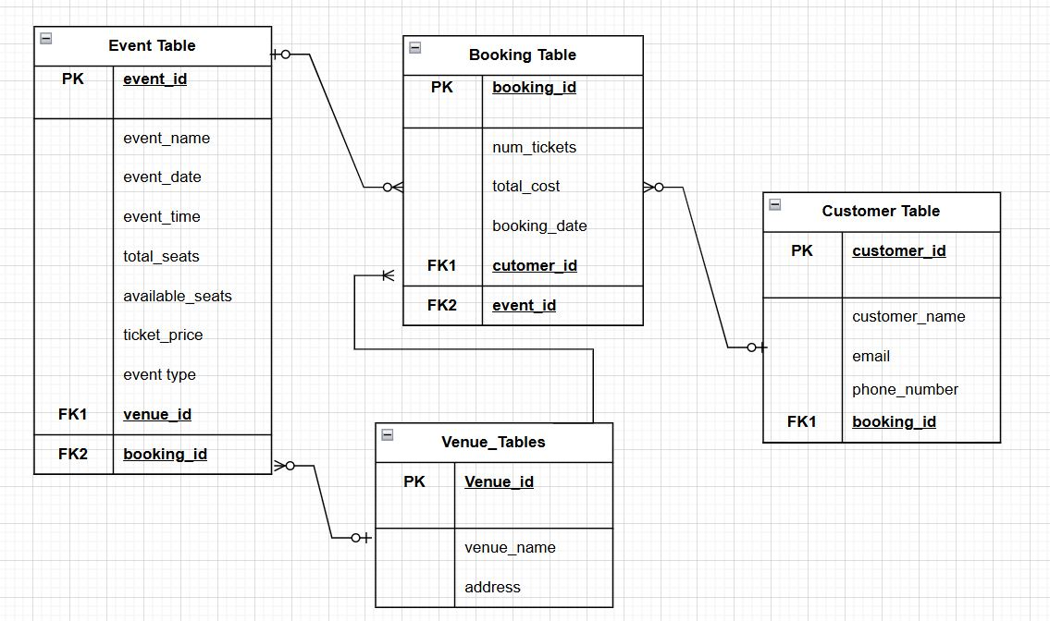

1. **Create appropriate Primary Key and Foreign Key constraints for referential integrity.**

**Adding foreign key to the tables.**

**• Event_Tables**

1.alter table Event_Table add constraint eventtable_eventid_pk primary key (event_id);

2.alter table Event_Table add constraint venueid_fk FOREIGN KEY (venue_id) references Venue_Tables(venue_id);

3.alter table Event_Table add constraint custable_bid_fk FOREIGN KEY (booking_id) references Booking_Table(booking_id);

4.desc Event_Table;

+-----------------+----------------------------------+------+-----+---------+-------+

| Field | Type | Null | Key | Default | Extra |

+-----------------+----------------------------------+------+-----+---------+-------+

| event_id | int | NO | PRI | NULL | |

| event_name | varchar(30) | YES | | NULL | |

| event_date | date | YES | | NULL | |

| event_time | time | YES | | NULL | |

| venue_id | int | YES | MUL | NULL | |

| total_seats | int | YES | | NULL | |

| available_seats | int | YES | | NULL | |

| ticket_price | decimal(10,2) | YES | | NULL | |

| event_type | enum('Movie','Sports','Concert') | YES | | NULL | |

| booking_id | int | YES | MUL | NULL | |

+-----------------+----------------------------------+------+-----+---------+-------+

**• Customers_Table:**

1.alter table Customer_Table add CONSTRAINT bookingid_fk FOREIGN KEY (booking_id) references Booking_Table(booking_id);

2.desc Customer_Table;

+---------------+--------------+------+-----+---------+-------+

| Field | Type | Null | Key | Default | Extra |

+---------------+--------------+------+-----+---------+-------+

| customer_id | int | NO | PRI | NULL | |

| customer_name | varchar(20) | YES | | NULL | |

| email | varchar(200) | YES | | NULL | |

| phone_number | int | YES | | NULL | |

| booking_id | int | YES | MUL | NULL | |

+---------------+--------------+------+-----+---------+-------+

**• Booking_Table:**

1.alter table Booking_Table add CONSTRAINT bookingtable_cid_fk FOREIGN KEY (customer_id) references Customer_Table(customer_id);

2.alter table Booking_Table add CONSTRAINT bookingtable_eid_fk FOREIGN KEY (event_id) references Event_Table(event_id);

3.desc Booking_Table;

+-------------+---------------+------+-----+---------+-------+

| Field | Type | Null | Key | Default | Extra |

+-------------+---------------+------+-----+---------+-------+

| booking_id | int | NO | PRI | NULL | |

| customer_id | int | YES | MUL | NULL | |

| event_id | int | YES | MUL | NULL | |

| num_tickets | int | YES | | NULL | |

| total_cost | decimal(10,2) | YES | | NULL | |

| boking_date | date | YES | | NULL | |

+-------------+---------------+------+-----+---------+-------+

**5.To insert all the values in the table**

**Venue_Tables:**

insert into Venue_Tables(venue_id, venue_name, address) values (1 , 'Theatre Arena' , ' chennai') , (2 , 'Silver Screen' , 'chennai') , (3 , 'Movie magic' , 'chennai') , (4 ,'Music Venue' , 'chennai') , (5 , 'sound stage' , 'chennai' ) , (6 , 'Classic Fusion' , 'chennai') , (7 , 'Game Stadium' , 'chennai') , (8 , 'Sports Venue' , 'chennai') , (9 , 'playground Arena' , 'chennai') , (10, 'champion field' , 'chennai');

**Event_Table:**

insert into Event_Table values ( 201 , 'Avengers The End Game' ,'2025-03-02' , '09:00:00' , 1 , 300 , 300 , 200 , 'Movie' , null) , (203 , 'Fault in our stars' ,'2025-03-05' , '09:00:00' ,3, 200 ,200, 250 , 'Movie' , null) , (204 , 'Folk' , '2025-03-06' , '10:00:00' , 4 , 400 , 400 , 150 , 'Concert' , null ) ,(205 , 'Melody Evening' , '2025-03-08' , '17:00:00' , 5 , 300 , 300 , 250 , 'Concert' , null) , (206 , 'Rythm Party' , '2025-03-09' , '16:00:00' , 6 , 250 , 250 , 150 , 'Concert',null ) , (207 , 'Basket Ball' , '2025-03-08' , '13:00:00' , 7 , 400 , 400, 350 , 'Sports',null ), (208 , 'Fun Run Challenge' , '2025-03-09' , '13:00:00' , 8 , 500 , 500, 300, 'Sports' , null ) , (209 , 'Cricket' , '2025-03-10' , '13:00:00' , 9 , 1000 , 100, 600, 'Sports' , null ) , (210 , 'Football' , '2025-03-11' , '10:00:00' , 10 , 500 , 500, 300, 'Sports' , null);

**Customer_Table:**

insert Customer_Table values (301 , 'priya' , 'priya12@gamil.com' , 34556780, null ), (302 , 'preethi' , 'preethi12@gamil.com' , 34556450,null) , (303, 'ram' , 'ram12@gamil.com' , 3458975,null) , (304 , 'raghul' ,' raghul23@gmail.com' , 4568975,null) ,(305 , 'raj' ,' rajl23@gmail.com' , 4568764,null),(306 , 'ramya' ,' ramya233@gmail.com' , 2345987,null) , (307 , 'anjali' ,' anjali3@gmail.com' , 3455782,null),(308 , 'harish' ,' harish33@gmail.com' , 558462076,null) , (309 , 'arjun' ,' arjun3@gmail.com' , 54638262,null), (310 , 'ramesh' ,' ramesh33@gmail.com' , 5584658,null);

**Booking_Table:**

insert into BOOKING_Table values (401 , 301 , 201 , 1 ,1000, '2025-02-20') , (402 , 302 , 202 , 2 , 4000, '2025-02-21'), (403 , 303 , 203 , 3 , 12000 , '2025-02-21') , (404 , 304 , 204 , 1 , 6000 , '2025-02-21') , (405 , 305 , 205 , 4 , 6000, '2025-02-22') , (406 , 306 , 206 , 2 , 6000 , '2025-02-23') , (407 , 307 , 207 , 1 , 2500 , '2025-02-26') , (408 , 308 , 208 , 5 , 17500 , '2025-02-28') , (409 , 309 , 209 , 1 ,500 , '2025-02-28') , (410 , 310 , 210 , 2 , 9000, '2025-02-27');

update Event_Table set booking_id = case when event_id = 201 then 401 when event_id = 202 then 402 when event_id = 203 then 403 when event_id = 204 then 404 when event_id = 205 then 405 when event_id = 206 then 406 when event_id = 207 then 407 when event_id = 208 then 408 when event_id = 209 then 409 when event_id = 210 then 410 else booking_id end where booking_id is null;

update Customer_Table set booking_id = case when customer_id = 301 then 401 when customer_id = 302 then 402 when customer_id = 303 then 403 when customer_id = 304 then 404 when customer_id = 305 then 405 when customer_id = 306 then 406 when customer_id = 307 then 407 when customer_id = 308 then 408 when customer_id = 309 then 409 when customer_id = 310 then 410 else booking_id end where booking_id is null;